Software Requirements Specification
For
SAADHANA AND GAANA
Version 1.0 approved
Prepared by M.Vishwajeet
N.Preetham Reddy
M.Moulika
<organization> eSwara
<date created> 30-8-18
Table of Contents
Table of Contents ii
Revision History ii
1. Introduction 1
1.1 Purpose 1
1.2 Document Conventions 1
1.3 Intended Audience and Reading Suggestions 1
1.4 Product Scope 1
1.5 References 1
2. Overall Description 2
2.1 Product Perspective 2
2.2 Product Functions 2
2.3 User Classes and Characteristics 2
2.4 Operating Environment 2
2.5 Design and Implementation Constraints 2
2.6 User Documentation 2
2.7 Assumptions and Dependencies 3
3. External Interface Requirements 3
3.1 User Interfaces 3
3.2 Hardware Interfaces 3
3.3 Software Interfaces 3
3.4 Communications Interfaces 3
4. System Features 4
4.1 System Feature 1 4
4.2 System Feature 2 (and so on) 4
5. Other Nonfunctional Requirements 4
5.1 Performance Requirements 4
5.2 Safety Requirements 5
5.3 Security Requirements 5
5.4 Software Quality Attributes 5
5.5 Business Rules 5
6. Other Requirements 5
Appendix A: Glossary 5
Appendix B: Analysis Models 5
Appendix C: To Be Determined List 6

Revision History
Name | Date | Reason For Changes | Version

Introduction

Purpose
The project consist of two android application Sadhana and Gaana,The main purpose of this project is that the user can play a song in Sadhana and can record his voice in Gaana .

Document Conventions
- OS-Operating system

Intended Audience and Reading Suggestions
- I prefer the document to be read in the order
- The Main Purpose of this project(UNIT-1).
- External Interface Requirements(UNIT-3).
- Overall Description.(UNIT-2)
- System Features(UNIT-4).
- Other Nonfunctional Requirements(UNIT-5)

Product Scope
We know that the project consist of two applications i.e.,Sadhana and Gaana.The main purpose of this project is that the user can play a song in Sadhana and can record his voice in Gaana .The other purpose is that playing a song in a loop without a glitche in an android phone.

References
<List any other documents or Web addresses to which this SRS refers. These may include user interface style guides, contracts, standards, system requirements specifications, use case documents, or a vision and scope document. Provide enough information so that the reader could access a copy of each reference, including title, author, version number, date, and source or location.>

Overall Description

Product Perspective
We could say that Saadhana is an replacement of a music player and Gaana is an replacement of a Recorder. There is a Simple Diagram given below which shows the major components and interconnections.

Product Functions
- In our two applications, the user must play the music in saadhana and in Gaana the user must sing and record there song .
- There will be 32 musics which can be selected by the user in saadhana .
- These 32 musics will be divided into 12 sectors in which each sector consist of 3 Toggle buttons to choose.

User Classes and Characteristics
- Developers
- Customer(Faculty)
- Users
Developers:
They fix the bugs
They can create new interface, like adding new updates
Customer:
- Adding events
- upload materials
- Search for user details
Users
- Changing passwords
- Updating details
- Searching for details

Operating Environment
The Application will work only on Android OS,and the hardware platform is only where Android OS installed in the hardware example- We can install Blue Stacks in Windows to use the App.

Design and Implementation Constraints
- Excel export has not been developed for Sadhana due to some Criticality.
- We needed atleast 16gb Ram to develop the Sadhana and Gaana because we need to use two simulators at a time which makes our system slow with less Ram.

User Documentation

Assumptions and Dependencies
Still we did not find any opposing factor. We may get a problem of data redundancy

External Interface Requirements

User Interfaces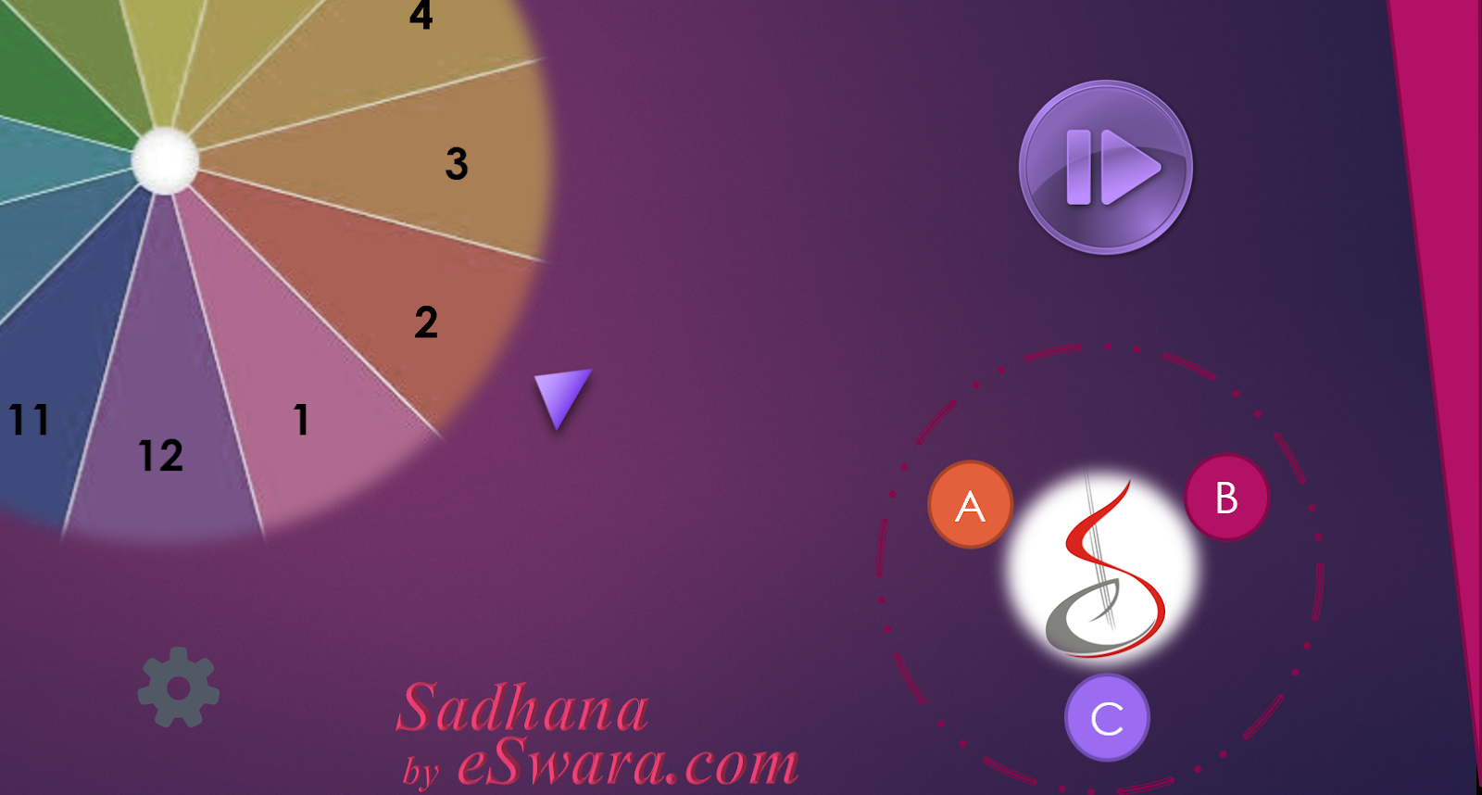
Basic Characteristics-
- Spinner Wheel- Used for selecting the type of the music.
- Toggle buttons-Used for selecting music.
- Pause/Stop- Functions as it named.
- Settings - Changing the password,Report(Feedback)

Hardware Interfaces
- The device not be connected to internet to use this application.
- This system can be accessed even in android mobiles.
- This application can be access through system given further details in the Secion:3.3.

Software Interfaces
- Android OS
- Windows where we can install android OS and can access the application.
- Android Studio
- EMULATORS
- Github libraries
- My sql

Communications Interfaces
We are using transport network layer.

System Features
<This template illustrates organizing the functional requirements for the product by system features, the major services provided by the product. You may prefer to organize this section by use case, mode of operation, user class, object class, functional hierarchy, or combinations of these, whatever makes the most logical sense for your product.>

System Feature 1
<Don’t really say “System Feature 1.” State the feature name in just a few words.>
4.1.1 Description and Priority
<Provide a short description of the feature and indicate whether it is of High, Medium, or Low priority. You could also include specific priority component ratings, such as benefit, penalty, cost, and risk (each rated on a relative scale from a low of 1 to a high of 9).>
4.1.2 Stimulus/Response Sequences
<List the sequences of user actions and system responses that stimulate the behavior defined for this feature. These will correspond to the dialog elements associated with use cases.>
4.1.3 Functional Requirements
<Itemize the detailed functional requirements associated with this feature. These are the software capabilities that must be present in order for the user to carry out the services provided by the feature, or to execute the use case. Include how the product should respond to anticipated error conditions or invalid inputs. Requirements should be concise, complete, unambiguous, verifiable, and necessary. Use “TBD” as a placeholder to indicate when necessary information is not yet available.>

<Each requirement should be uniquely identified with a sequence number or a meaningful tag of some kind.>

REQ-1:
REQ-2:

System Feature 2 (and so on)

Other Nonfunctional Requirements

Performance Requirements
If the user wants to plays the music , he must select the tune from the wheel which contains 12 types of tunes and must spin the selected tune to the arrow .There will be no time delay in the output .There will be three buttons near that wheel which contains one music each. This wheel and buttons should be played simultaneously.

Safety Requirements
The Info of music should be securely transmitted to server without any changes in information .There should not be any overlapping between the two musics in one sector.

Security Requirements
There should be proper sign-in and sign-up mechanism for the users that will prevent the software from hacking. When you sign up through your mobile number , an OTP will be sent to make sure that your account is secure and a verification E-mail will be sent in case of other kinds of sign ups.

Software Quality Attributes
5.4.1 Availability
If the internet service gets disrupted while sending information to the server, the information can be send again for verification. The user can save, delete and edit there played music.

5.4.2 Usability
This application is easy to handle and output music will have no time delay. In the three buttons near the wheel only one button can be used at one time while using one button other two buttons can't be activated.

5.4.3 Correctness

In this application the composed music will be saved and we will record a song in other app and play saved song and music simultaneously.

5.4.4 Portability

The application is portable and supported in all the android mobiles in version 5.0 and above.

Business Rules
Under any circumstance, any modification to be done to the data or to the application, it will be completely in the hands of the administrator . The users who don’t log in are open to some features of the application as they are not considered reliable until they become verified users . The users who login are open to all the facilities and the features of the application .In the process of playing the music in the three buttons near the wheel only one button can be used at one time while the other two buttons can't be activated , once the user presses one of the button he can't perform any action on other buttons.

Other Requirements
- We are not using other requirements.
Appendix A: Glossary
<Define all the terms necessary to properly interpret the SRS, including acronyms and abbreviations. You may wish to build a separate glossary that spans multiple projects or the entire organization, and just include terms specific to a single project in each SRS.>
Appendix B: Analysis Models
<Optionally, include any pertinent analysis models, such as data flow diagrams, class diagrams, state-transition diagrams, or entity-relationship diagrams.>
Appendix C: To Be Determined List
<Collect a numbered list of the TBD (to be determined) references that remain in the SRS so they can be tracked to closure.>

